**T3TECJ – 2024**

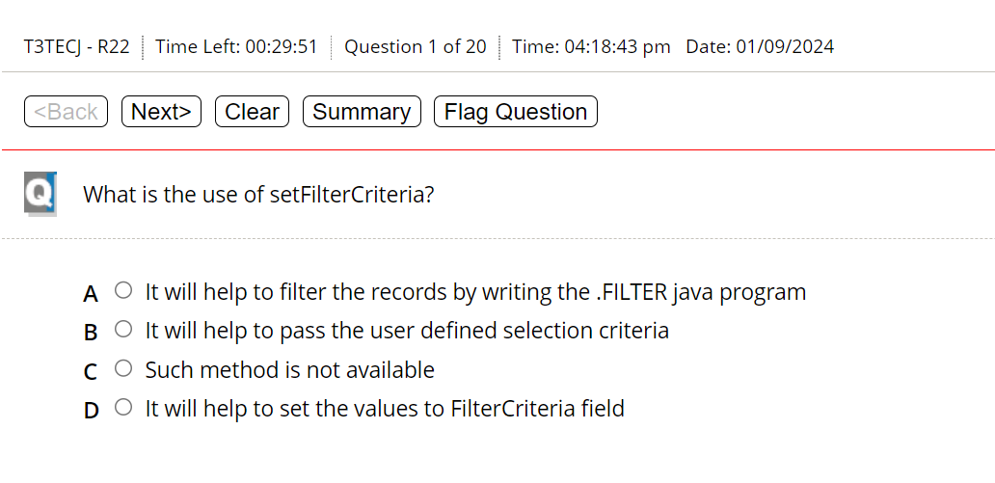

D

C

D

C

B

D

D

B

C

C

C

A

A

C?

D

C/D?

E

C

A

